**EXPERIMENT 3**

**Aim**:Design a web page including Client side scripting-Javascript.

**Theory:**

Javascript is the programming language of Html and the web.

JavaScript is one of the 3 languages all web developers must learn:

1. HTML to define the content of web pages

2. CSS to specify the layout of web pages

3. JavaScript to program the behavior of web pages

Web pages are not the only place where JavaScript is used. Many desktop and server programs use JavaScript. Node.js is the best known. Some databases, like MongoDB and CouchDB, also use JavaScript as their programming language.

JavaScript statements are composed of:

Values, Operators, Expressions, Keywords, and Comments.

A JavaScript function is a block of code designed to perform a particular task.

A JavaScript function is executed when "something" invokes it (calls it).

The window object represents an open window in a browser.

If a document contain frames (<iframe> tags), the browser creates one window object for the HTML document, and one additional window object for each frame.

**Implementation:**

Main.html

<!DOCTYPE html>  
<html lang="en" xmlns:color="http://www.w3.org/1999/xhtml">  
<head>  
 <link rel="stylesheet" href="https://cdnjs.cloudflare.com/ajax/libs/font-awesome/4.7.0/css/font-awesome.min.css">  
 <meta charset="UTF-8">  
 <title>SPitmeds- The Online Pharmacy</title>  
 <link href="Spitmeds.css" rel="stylesheet">  
 <meta name="viewport" content="width=device-width, initial-scale=1">  
 <script src="HomePageJavaScript.js">  
 </script>  
  
</head>  
  
<body>  
  
<div class="Top">  
 <div class="Head" >  
 <p><b>SPitmeds.com<sub id="tag">India ki online pharmacy</sub></b></p>  
 </div>  
 <div class="logoimg" style="width: 25%">  
 <img src="logo.jpg" id="logoimg1" >  
 </div>  
</div>  
<div class="nav">  
 <div class="tab" >  
 <button class="tablinks" onclick="openWinHome()">HOME</button>  
 <button class="tablinks">PRESCRIPTIONS</button>  
 <button class="tablinks">PERSONAL CARE</button>  
 <button class="tablinks">LIFESTYLE</button>  
 <button class="tablinks">TREATMENTS</button>  
 <button class="tablinks">HEALTH LIBRARY</button>  
 <button class="tablinks">DEVICES</button>  
 </div>  
 <div class="signinbutton">  
 <button class="tablinks" onclick="openWinSignup()">SIGN-IN</button>  
 </div>  
 <div>  
 <p style="padding: 10px;">OR</p>  
 </div>  
 <div class="registerbutton">  
 <button class="tablinks" onclick="openWin()">REGISTER</button>  
 </div>  
</div>  
  
  
<div class="Search_content" style="display: inline-flex">  
 <div class="search_bar">  
 <form class="example" style="margin-left:115px;max-width:650px">  
 <input type="text" placeholder="Search for Medicines... " name="search2">  
 <button type="submit"><i class="fa fa-search"></i></button>  
 </form>  
 </div>  
 <div class="orclass">  
 <p><b>OR</b></p>  
 </div>  
 <div class="uploadbuttonc" style="padding: 15px;width: auto;display: inline-flex;margin-left: 48px;">  
 <button id="uploadbutton">UPLOAD PRESCRIPTION</button>  
 </div>  
</div>  
  
<div class="row">  
 <div class="column" style="background-color:pink; margin-left: 75px; margin-bottom: 8px; margin-top: 8px">  
 <img src="cold.jpg" style="display: block; vertical-align: middle;padding: 8px; width:321.017px; height: 300px">  
 <p id="coldnfever">COLD & FEVER</p>  
 </div>  
 <div class="column" style="background-color:pink; margin-left: 8px; margin-bottom: 8px; margin-top: 8px">  
 <img src="bone.jpg" style="display: block; vertical-align: middle;padding: 8px; width: 321.017px; height: 300px">  
 <p id="bonecare">BONE CARE</p>  
 </div>  
 <div class="column" style="background-color:pink; margin-left: 8px; margin-bottom: 8px; margin-top: 8px">  
 <img src="lung.jpg" style="display: block; vertical-align: middle;padding: 8px; width:321.017px; height: 300px">  
 <p id="lungcare">LUNG CARE</p>  
</div>  
 <div class="column" style="background-color:pink; margin-left: 8px; margin-bottom: 8px; margin-top: 8px">  
 <img src="diabetes.jpg" style="display: block; vertical-align: middle;padding: 8px; width:321.017px; height: 300px">  
 <p id="diabetescare">DIABETES CARE</p>  
</div>  
  
</div>  
<div class="Sub-class">  
 <div class="midsection" style="display:inline-flex; margin-bottom: 15px">  
 <div style="margin-top: 15px; margin-left: 10px">  
 <img src="cross.jpg" style="width: 350px; height: 250px; border-radius: 50%;">  
 <img src="doctor2.jpg" style="width: 350px;height: 500px">  
 </div>  
 <div style="margin-left: 50px; margin-right: 150px">  
 <p style="font-size: 20px;margin-top: 15px;margin-bottom: 15px; padding-top:10px;"><b>Welcome to SPitmeds.com! SPIT's Leading Online Pharmacy – 1.5 Years of Trust!</b></p>  
 <p >With a long legacy of over 100 years in the pharma business, SPitmeds.com is the first choice of <b>Online Pharmacy India</b> for over 5000+ satisfied students, delivering health essentials to every branch in the college. Enjoy excellent service here at SPitmeds.com only!</p>  
 <p style="font-size: 20px;margin-top: 15px;margin-bottom: 15px; padding-top:10px;"><b>Take the Worry Out of Buying Medicines! Conveniently Purchase Medicines Online Anytime, Anywhere!</b></p>  
 <p style="margin-bottom: 15px">At <SPit></SPit>meds.com get everything you need to take care of your health from high-quality, affordable prescription medicines, over-the-counter pharmaceuticals to general health care products, Ayurveda and Homeopathy medicines.</p>  
 <p style="margin-bottom: 15px">Right at the comfort of your home, <b>buy medicines online</b> at SPitmeds.com to get them delivered straight to your door anywhere across India. Do away with the hassles of driving to the Medicine store, waiting in line, or even remembering your refills!</p>  
 <p>Ordering medicines online at SPitmeds.com is as simple as browsing through our range, adding to your cart and uploading your prescription, if required, and proceeding to checkout. Rest assured that you get greater peace of mind when you choose SPitmeds for all your healthcare needs!</p>  
 <p style="font-size: 20px;margin-top: 15px;margin-bottom: 15px; padding-top:10px;"><b>Our Awards and Recognition</b></p>  
 <p style="margin-bottom: 15px">We, at SPitmeds, know how crucial medicine is to treating health conditions and we are extremely proud to be at the forefront of the online medicine industry. SPitmeds offers its customers with a reliable online pharmacy service and as a testament to our commitment, we are regularly recognised and honoured with awards.</p>  
 <p>We are pleased to highlight some of our awards here... and we aim to continue adding more feathers to our cap: We have bagged the Health Tech Start Up of the Year at the <b>SPARK Awards 2016</b>. We are also proud that we have been selected as <b>‘SPIT’s Most Promising Brand 2019’</b> by Int+ WCRC International.</p>  
 <p style="font-size: 20px;margin-top: 15px;margin-bottom: 15px; padding-top:10px;"><b>Why choose SPitmeds.com?</b></p>  
 <ul style="margin: 15px">  
 <li style="margin-bottom: 5px">Over 100 Years of Service in the Pharma Industry</li>  
 <li style="margin-bottom: 5px">No Limits! Delivery All Across SPit</li>  
 <li style="margin-bottom: 5px">Family Pharmacy of choice for 3 Million+ Indians</li>  
 <li style="margin-bottom: 5px">High-Quality, Genuine Medicines</li>  
 <li style="margin-bottom: 5px">A Team of Highly Experienced Pharmacists</li>  
 <li style="margin-bottom: 5px">State-of-the Art Warehouses</li>  
 <li style="margin-bottom: 5px">A Large Inventory of Medicines/35000+ SKUs</li>  
 <li style="margin-bottom: 5px">Get to Know About the Expiry of medicines While Ordering itself!</li>  
 </ul>  
 </div>  
 <div style="margin-top: 30px">  
 <img src="vert.jpg">  
 </div>  
 </div>  
  
 <div class="footer">  
  
 </div>  
</div>  
  
</body>  
</html>

<!DOCTYPE html>  
<html lang="en" xmlns:color="http://www.w3.org/1999/xhtml">  
<head>  
 <link rel="stylesheet" href="https://cdnjs.cloudflare.com/ajax/libs/font-awesome/4.7.0/css/font-awesome.min.css">  
 <meta charset="UTF-8">  
 <title>SPitmeds- The Online Pharmacy</title>  
 <link href="Spitmeds.css" rel="stylesheet">  
 <meta name="viewport" content="width=device-width, initial-scale=1">  
 <script src="HomePageJavaScript.js">  
 </script>  
  
</head>  
  
<body>  
  
<div class="Top">  
 <div class="Head" >  
 <p><b>SPitmeds.com<sub id="tag">India ki online pharmacy</sub></b></p>  
 </div>  
 <div class="logoimg" style="width: 25%">  
 <img src="logo.jpg" id="logoimg1" >  
 </div>  
</div>  
<div class="nav">  
 <div class="tab" >  
 <button class="tablinks" onclick="openWinHome()">HOME</button>  
 <button class="tablinks">PRESCRIPTIONS</button>  
 <button class="tablinks">PERSONAL CARE</button>  
 <button class="tablinks">LIFESTYLE</button>  
 <button class="tablinks">TREATMENTS</button>  
 <button class="tablinks">HEALTH LIBRARY</button>  
 <button class="tablinks">DEVICES</button>  
 </div>  
 <div class="signinbutton">  
 <button class="tablinks" onclick="openWinSignup()">SIGN-IN</button>  
 </div>  
 <div>  
 <p style="padding: 10px;">OR</p>  
 </div>  
 <div class="registerbutton">  
 <button class="tablinks" onclick="openWin()">REGISTER</button>  
 </div>  
</div>  
  
  
<div class="Search_content" style="display: inline-flex">  
 <div class="search_bar">  
 <form class="example" style="margin-left:115px;max-width:650px">  
 <input type="text" placeholder="Search for Medicines... " name="search2">  
 <button type="submit"><i class="fa fa-search"></i></button>  
 </form>  
 </div>  
 <div class="orclass">  
 <p><b>OR</b></p>  
 </div>  
 <div class="uploadbuttonc" style="padding: 15px;width: auto;display: inline-flex;margin-left: 48px;">  
 <button id="uploadbutton">UPLOAD PRESCRIPTION</button>  
 </div>  
</div>  
  
<div class="row">  
 <div class="column" style="background-color:pink; margin-left: 75px; margin-bottom: 8px; margin-top: 8px">  
 <img src="cold.jpg" style="display: block; vertical-align: middle;padding: 8px; width:321.017px; height: 300px">  
 <p id="coldnfever">COLD & FEVER</p>  
 </div>  
 <div class="column" style="background-color:pink; margin-left: 8px; margin-bottom: 8px; margin-top: 8px">  
 <img src="bone.jpg" style="display: block; vertical-align: middle;padding: 8px; width: 321.017px; height: 300px">  
 <p id="bonecare">BONE CARE</p>  
 </div>  
 <div class="column" style="background-color:pink; margin-left: 8px; margin-bottom: 8px; margin-top: 8px">  
 <img src="lung.jpg" style="display: block; vertical-align: middle;padding: 8px; width:321.017px; height: 300px">  
 <p id="lungcare">LUNG CARE</p>  
</div>  
 <div class="column" style="background-color:pink; margin-left: 8px; margin-bottom: 8px; margin-top: 8px">  
 <img src="diabetes.jpg" style="display: block; vertical-align: middle;padding: 8px; width:321.017px; height: 300px">  
 <p id="diabetescare">DIABETES CARE</p>  
</div>  
  
</div>  
<div class="Sub-class">  
 <div class="midsection" style="display:inline-flex; margin-bottom: 15px">  
 <div style="margin-top: 15px; margin-left: 10px">  
 <img src="cross.jpg" style="width: 350px; height: 250px; border-radius: 50%;">  
 <img src="doctor2.jpg" style="width: 350px;height: 500px">  
 </div>  
 <div style="margin-left: 50px; margin-right: 150px">  
 <p style="font-size: 20px;margin-top: 15px;margin-bottom: 15px; padding-top:10px;"><b>Welcome to SPitmeds.com! SPIT's Leading Online Pharmacy – 1.5 Years of Trust!</b></p>  
 <p >With a long legacy of over 100 years in the pharma business, SPitmeds.com is the first choice of <b>Online Pharmacy India</b> for over 5000+ satisfied students, delivering health essentials to every branch in the college. Enjoy excellent service here at SPitmeds.com only!</p>  
 <p style="font-size: 20px;margin-top: 15px;margin-bottom: 15px; padding-top:10px;"><b>Take the Worry Out of Buying Medicines! Conveniently Purchase Medicines Online Anytime, Anywhere!</b></p>  
 <p style="margin-bottom: 15px">At <SPit></SPit>meds.com get everything you need to take care of your health from high-quality, affordable prescription medicines, over-the-counter pharmaceuticals to general health care products, Ayurveda and Homeopathy medicines.</p>  
 <p style="margin-bottom: 15px">Right at the comfort of your home, <b>buy medicines online</b> at SPitmeds.com to get them delivered straight to your door anywhere across India. Do away with the hassles of driving to the Medicine store, waiting in line, or even remembering your refills!</p>  
 <p>Ordering medicines online at SPitmeds.com is as simple as browsing through our range, adding to your cart and uploading your prescription, if required, and proceeding to checkout. Rest assured that you get greater peace of mind when you choose SPitmeds for all your healthcare needs!</p>  
 <p style="font-size: 20px;margin-top: 15px;margin-bottom: 15px; padding-top:10px;"><b>Our Awards and Recognition</b></p>  
 <p style="margin-bottom: 15px">We, at SPitmeds, know how crucial medicine is to treating health conditions and we are extremely proud to be at the forefront of the online medicine industry. SPitmeds offers its customers with a reliable online pharmacy service and as a testament to our commitment, we are regularly recognised and honoured with awards.</p>  
 <p>We are pleased to highlight some of our awards here... and we aim to continue adding more feathers to our cap: We have bagged the Health Tech Start Up of the Year at the <b>SPARK Awards 2016</b>. We are also proud that we have been selected as <b>‘SPIT’s Most Promising Brand 2019’</b> by Int+ WCRC International.</p>  
 <p style="font-size: 20px;margin-top: 15px;margin-bottom: 15px; padding-top:10px;"><b>Why choose SPitmeds.com?</b></p>  
 <ul style="margin: 15px">  
 <li style="margin-bottom: 5px">Over 100 Years of Service in the Pharma Industry</li>  
 <li style="margin-bottom: 5px">No Limits! Delivery All Across SPit</li>  
 <li style="margin-bottom: 5px">Family Pharmacy of choice for 3 Million+ Indians</li>  
 <li style="margin-bottom: 5px">High-Quality, Genuine Medicines</li>  
 <li style="margin-bottom: 5px">A Team of Highly Experienced Pharmacists</li>  
 <li style="margin-bottom: 5px">State-of-the Art Warehouses</li>  
 <li style="margin-bottom: 5px">A Large Inventory of Medicines/35000+ SKUs</li>  
 <li style="margin-bottom: 5px">Get to Know About the Expiry of medicines While Ordering itself!</li>  
 </ul>  
 </div>  
 <div style="margin-top: 30px">  
 <img src="vert.jpg">  
 </div>  
 </div>  
  
 <div class="footer">  
  
 </div>  
</div>  
  
</body>  
</html>

Sign-in.html

<!DOCTYPE html>  
<html lang="en" xmlns:color="http://www.w3.org/1999/xhtml">  
<head>  
 <title>Sign-up</title>  
 <link href="Sign-in-css.css" rel="stylesheet">  
 <meta name="viewport" content="width=device-width, initial-scale=1">  
  
 <script src="SignUpJavaScript.js"></script>  
</head>  
<body>  
<div class="Top">  
 <div class="Head" >  
 <p ><b>SPitmeds.com<sub id="tag">India ki online pharmacy</sub></b></p>  
 </div>  
 <div class="logoimg" style="width: 25%">  
 <img src="logo.jpg" id="logoimg1" >  
 </div>  
</div>  
<div class="nav">  
 <div class="tab" >  
 <button class="tablinks" onclick="openWinHome()">HOME</button>  
 <button class="tablinks">PRESCRIPTIONS</button>  
 <button class="tablinks">PERSONAL CARE</button>  
 <button class="tablinks">LIFESTYLE</button>  
 <button class="tablinks">TREATMENTS</button>  
 <button class="tablinks">HEALTH LIBRARY</button>  
 <button class="tablinks">DEVICES</button>  
 </div>  
</div>  
  
  
<div class="Search_content" style="display: inline-flex">  
 <div class="search_bar">  
 <form class="example" style="margin-left:115px;max-width:650px">  
 <input type="text" placeholder="Search for Medicines... " name="search2">  
 <button type="submit"><i class="fa fa-search"></i></button>  
 </form>  
 </div>  
 <div class="orclass">  
 <p><b>OR</b></p>  
 </div>  
 <div class="uploadbuttonc" style="padding: 15px;width: auto;display: inline-flex;margin-left: 48px;">  
 <button id="uploadbutton">UPLOAD PRESCRIPTION</button>  
 </div>  
</div>  
  
  
  
<div class="middle" style="display: flex">  
 <div class="Inputdetails" style="width: 550px;margin-left: 25px;">  
 <h2 id="log" style="color: white;text-align: center; font-size: 25px; font-family: 'Leelawadee UI' ">Login Form</h2>  
  
 <form id="formsignin">  
 <div class="imgcontainer">  
 <img src="loginmale.png" class="avatar">  
 </div>  
  
 <div class="container">  
 <b style="color: white; font-size: 25px">Username</b>  
 <input type="text" placeholder="Enter Username" name="uname" required id="usernameinput">  
  
 <b style="color: white; font-size: 25px">Password</b>  
 <input type="password" placeholder="Enter Password" name="psw" required id="passwordinput">  
  
 <button type="submit" style="font-size: 20px" onclick="alertforlogin()">Login</button>  
 </div>  
  
 <div class="container1">  
 <button type="button" class="cancelbtn">Cancel</button>  
 <span class="psw"><a href="#"><b>Forgot password?</b></a></span>  
 </div>  
 </form>  
 </div>  
 <div style="margin: 25px;width: auto;margin-top: 0px">  
 <h1 style="color: white; text-align: center">Social Media Log in</h1>  
 <div class="col" style="width: 400px;margin-top: 10px">  
 <a href="#" class="fb btn" style="text-align: center">  
 <i class="fa fa-facebook fa-fw"></i> Login with Facebook  
 </a>  
 <a href="#" class="twitter btn" style="text-align: center">  
 <i class="fa fa-twitter fa-fw"></i> Login with Twitter  
 </a>  
 <a href="#" class="google btn" style="text-align: center">  
 <i class="fa fa-google fa-fw"></i> Login with Google+  
 </a>  
 </div>  
 </div>  
 <div style="margin: 50px">  
 <img name="slide" width="300px" height="auto" style="border-radius: 25px">  
 </div>  
 <script>  
  
 </script>  
</div>  
  
<div class="footer">  
  
</div>  
</body>  
</html>

body {  
  
 font-family: 'Sofia';  
}  
  
*{  
 margin: 0;  
 padding: 0;  
 box-sizing: border-box;  
}  
.Top{  
 display: inline-flex;  
 height: auto;  
 width: 100%;  
 margin-bottom: 8px;  
}  
.Head{  
 color: lightseagreen;  
 margin-left: 25px;  
 text-shadow: 6px 6px 15px gray;  
 font-size: 50px;  
 width: auto;  
 height: auto;  
 padding: 10px;  
 display: table-cell;  
}  
#tag{  
 float: inside;  
 color: green;  
 width: auto ;  
 font-size: 20px;  
 height: auto;  
}  
#logoimg1{  
  
 height: 100px;  
 float: left;  
 display: table-cell;  
 margin-left: 735px;  
 padding: 8px 0px 0px 10px;  
}  
  
  
.nav {  
 margin-top: 8px;  
 width: 100%;  
 height: auto;  
 text-align: center;  
 font-size: 25px;  
 display: inline;  
 margin-bottom: 10px;  
 vertical-align: unset;  
}  
  
  
.tab {  
 overflow: hidden;  
 background-color: #02b7c2;  
 border-radius: 25px;  
 margin-bottom: 10px;  
 margin-left: 10px;  
 margin-right: 10px;  
 display: flex;  
}  
.tab button {  
 background-color: inherit;  
 float: left;  
 border: none;  
 outline: none;  
 cursor: pointer;  
 transition: 0.3s;  
 font-size: 17px;  
  
}  
.tab button:hover {  
 background-color:lightblue;  
}  
.tablinks{  
 padding:10px;  
 color: white  
}  
  
  
  
  
.Search_content{  
 width: 100%;  
 height: auto;  
 margin: 0;  
 background: #02b7c2;  
 box-shadow: #222222;  
 border-radius: 20px;  
 margin-left: 5px;  
 margin-right: 5px;  
}  
.search_bar{  
 padding: 15px;  
 width: 700px;  
 display: inline-block;  
}  
form.example input[type=text] {  
 padding: 10px;  
 font-size: 17px;  
 border: 1px solid grey;  
 float: left;  
 width: 425px;  
 background: #f1f1f1;  
}  
form.example button {  
 width: 80px;  
 padding: 10px;  
 background: #2196F3;  
 color: white;  
 font-size: 17px;  
 border: 1px solid grey;  
 border-left: none;  
 cursor: pointer;  
}  
form.example button:hover {  
 background: #0b7dda;  
}  
  
.orclass{  
 padding-top: 15px;  
 padding-bottom: 15px;  
 width:auto;  
 display: inline-flex;  
 font-size: 25px;  
 margin-top: 5px;  
 color: white;  
}  
.uploadbuttonc button:hover{  
 background-color: #0b7dda;  
 cursor: pointer;  
}  
#uploadbutton{  
 width: 200px;  
 background: #2196F3;  
 color: white;  
 border-radius: 15px;  
}  
  
  
  
  
  
  
form {border: 3px solid #02b7c2 ;}  
  
#formsignin{  
 box-shadow: 8px 8px 25px black;  
 width: 505px;  
 border-radius: 25px;  
 margin: 10px;  
}  
  
input[type=text], input[type=password] {  
 width: 100%;  
 padding: 12px 20px;  
 margin: 8px 0;  
 display: inline-block;  
 border: 1px solid #ccc;  
 box-sizing: border-box;  
}  
  
button {  
 background-color: #4CAF50;  
 color: white;  
 padding: 14px 20px;  
 margin: 8px 0;  
 border: none;  
 cursor: pointer;  
 width: 100%;  
}  
  
button:hover {  
 opacity: 0.5;  
}  
  
.cancelbtn {  
 width: auto;  
 padding: 10px 18px;  
 background-color: #f44336;  
}  
  
.imgcontainer {  
 text-align:center;  
 width: 500px;  
 height: auto;  
 background: #02b7c2;  
 border-top-left-radius: 25px;  
 border-top-right-radius: 25px;  
}  
  
img.avatar {  
 width: 300px;  
 border-radius: 50%;  
 padding: 25px;  
}  
.middle{  
 background: darkcyan;  
 height: 740.483px;  
 margin: 8px;  
 border-radius: 20px;  
}  
  
  
  
/*  
different sign-in  
*/  
  
  
input,  
.btn {  
 width: 100%;  
 padding: 12px;  
 border: none;  
 border-radius: 10px;  
 margin: 5px 0;  
 opacity: 0.85;  
 display: inline-block;  
 font-size: 17px;  
 line-height: 20px;  
 text-decoration: none; /* remove underline from anchors */  
}  
  
input:hover,  
.btn:hover {  
 opacity: 0.7;  
}  
.fb {  
 background-color: #3B5998;  
 color: white;  
}  
  
.twitter {  
 background-color: #55ACEE;  
 color: white;  
}  
  
.google {  
 background-color: #dd4b39;  
 color: white;  
}  
.col {  
 float: left;  
 width: 50%;  
 margin: auto;  
 padding: 0 50px;  
 margin-top: 6px;  
}  
  
/* Clear floats after the columns */  
.row:after {  
 content: "";  
 display: table;  
 clear: both;  
}  
  
  
  
  
  
.container {  
 padding: 16px;  
 width: 500px;  
 background: #02b7c2;  
}  
  
  
  
.container1{  
 padding: 16px;  
 width: 500px;  
 background: #02b7c2;  
 border-bottom-right-radius: 25px;  
 border-bottom-left-radius: 25px;  
}  
  
  
span.psw {  
 float: right;  
 padding-top: 16px;  
}  
  
.footer{  
 margin-left: 8px;  
 margin-right: 8px;  
 margin-top: 8px;  
 height: 200px;  
 background: #02b7c2;  
 border-radius: 20px;  
  
}

JAVASCRIPT

**function** alertforlogin() {  
 window.alert("Are you sure to login?")  
}  
window.onload=changeimage;  
  
 **var** i=0;  
 **var** images=[];  
 **var** time=3000;  
  
 images[0]='images1.jpg';  
 images[1]='images3.jpg';  
 **function** changeimage() {  
 document.slide.src=images[i];  
 **if**(i<images.length-1){  
 i++;}  
 **else**{  
 i=0;  
 }  
 setTimeout("changeimage()", time);  
 }

**function** openWinSignup() {  
 window.open(href="http://localhost:63342/untitled1/src/SIgn-Up.html?_ijt=ifdqgt86ndomvl5kmp70qhe6lq");  
}  
**function** openWinHome() {  
 window.open(href="http://localhost:63342/untitled1/src/Spitmeds.html?_ijt=f8s6739op6mogkdokoun35usai");  
}

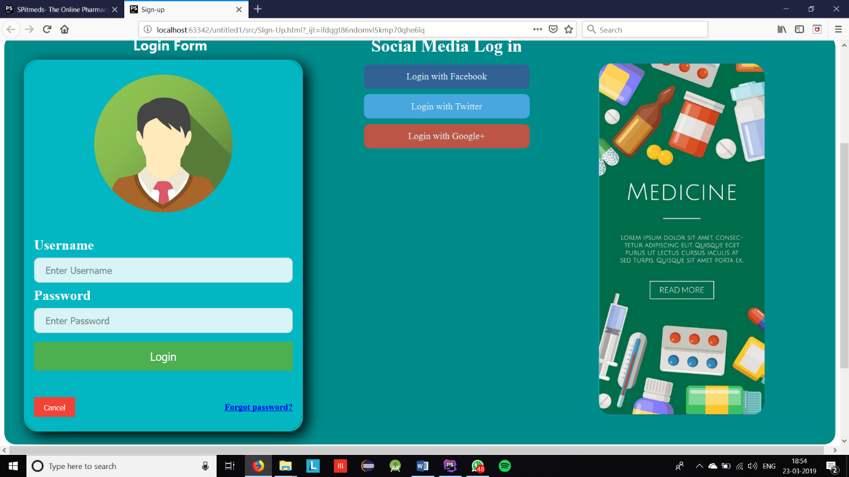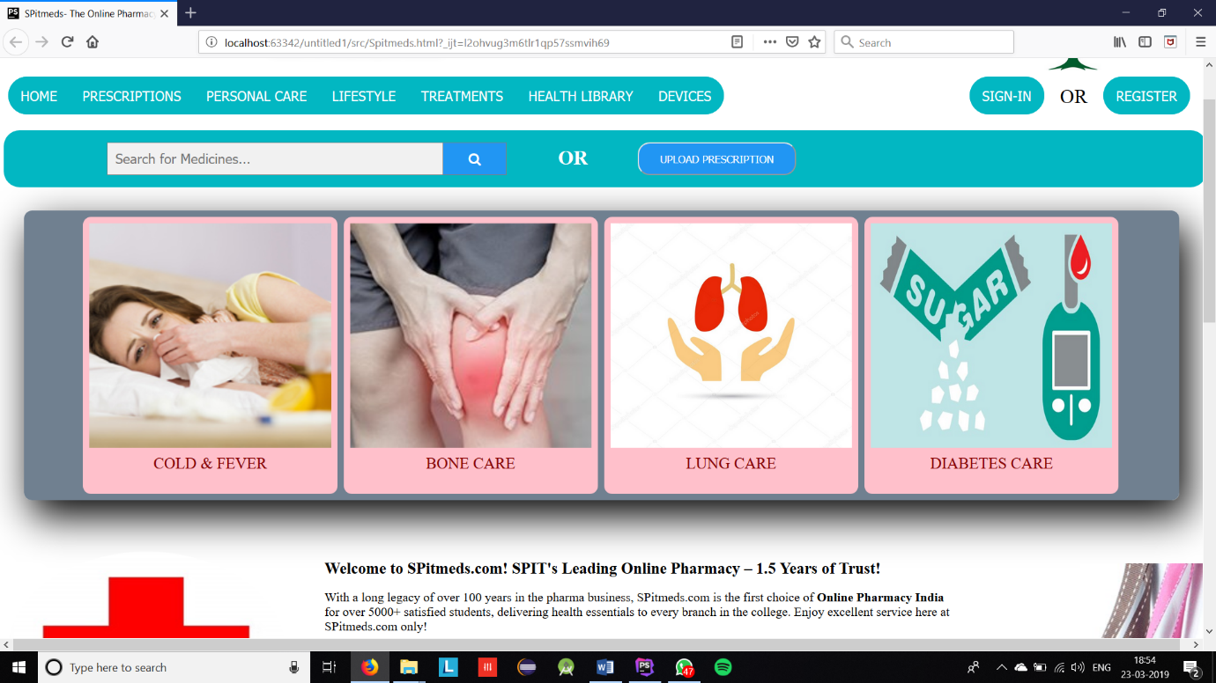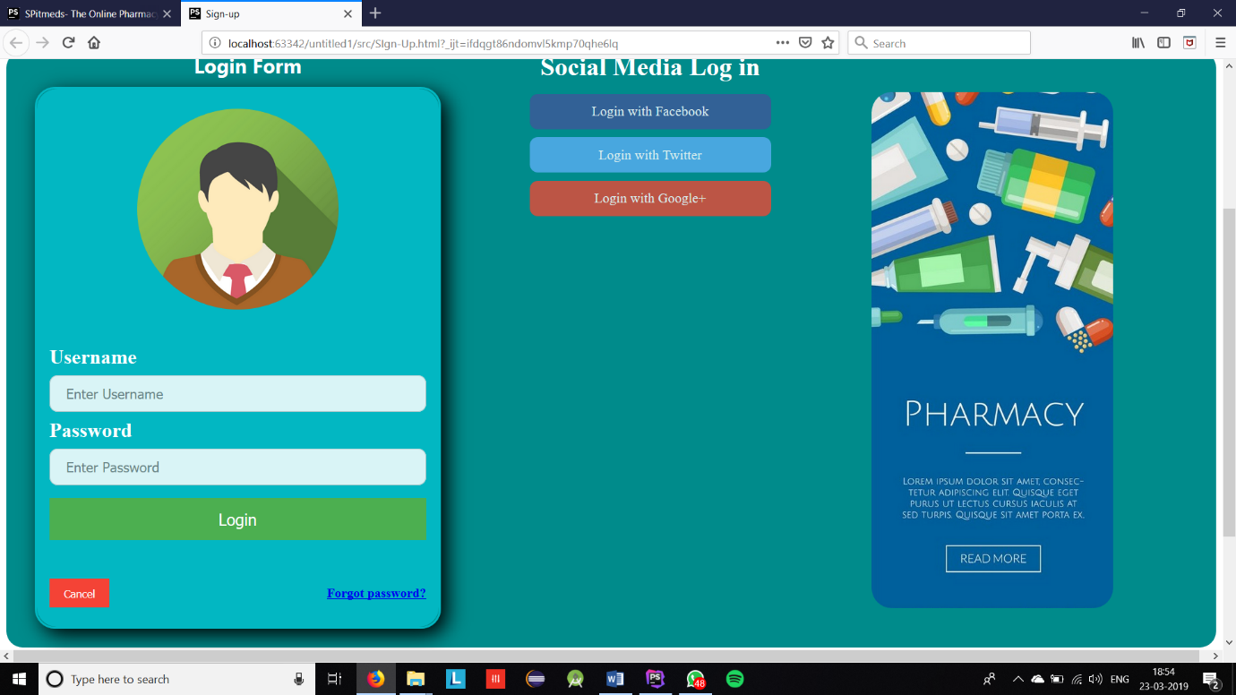

**Conclusion:**In this experiment, we have learnt how JavaScript can be used along with HTML and CSS to improve the UI of the website. JavaScript can calculate, manipulate and validate data.